Financial Closing Advisor — Demo Script
Video: ~9:40 | Financial Closing Advisor Agent | Joule Studio
Demo Action | Screenshot |  | VO
Joule Studio open. Financial Closing Advisor project in draft. Requirements panel shows empty state. Chat panel shows the intent prompt just submitted. | 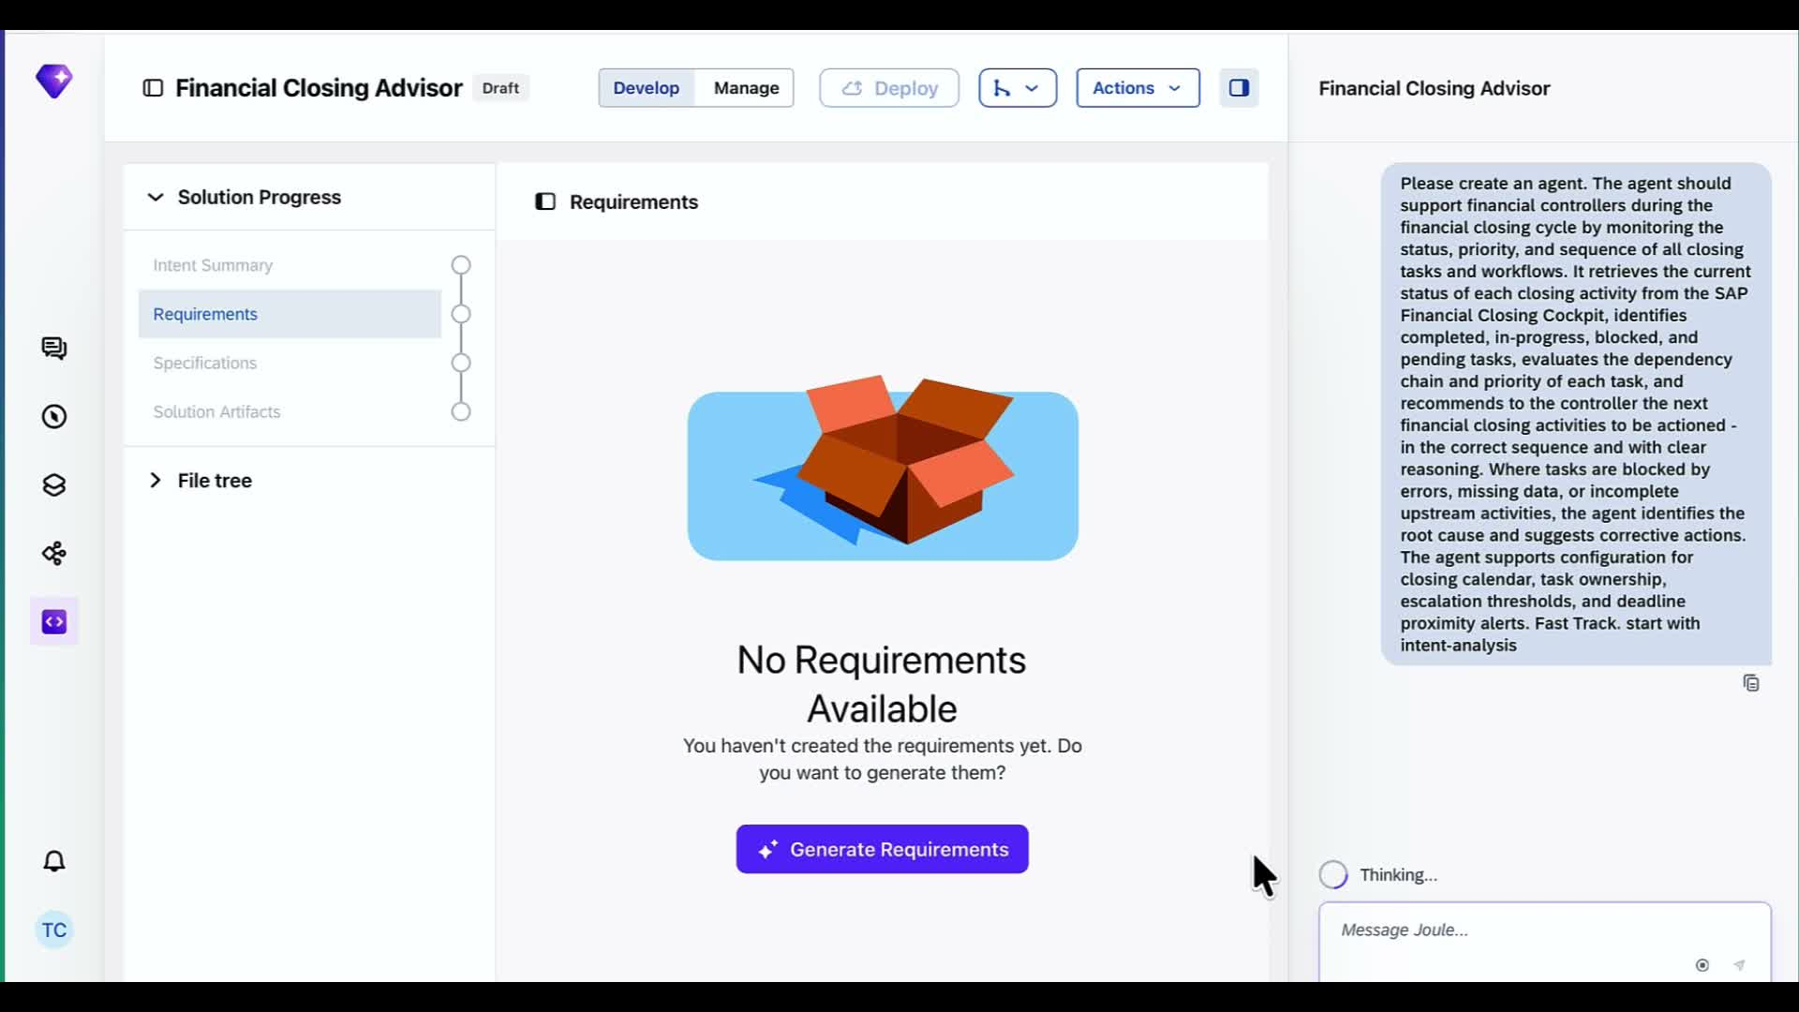 |  | Hey there, I'm Michael Ye from the SAP product marketing team.  Today we are going to build a finance AI agent from scratch — All in the next 10 minutes.  Let’s do it!  So here we are in Joule Studio, this is your agentic development environment.  Today I’ll write a prompt for building a Financial Closing Advisor.  . We want an AI agent track what tracks what tasks are blocked, why, and exactly what to do next.  I've just submitted the prompt and Joule Studio is off and running.
Joule reads the intent file, calls 4 tools, searches for MCP servers. Asks for target business metrics before proceeding. | 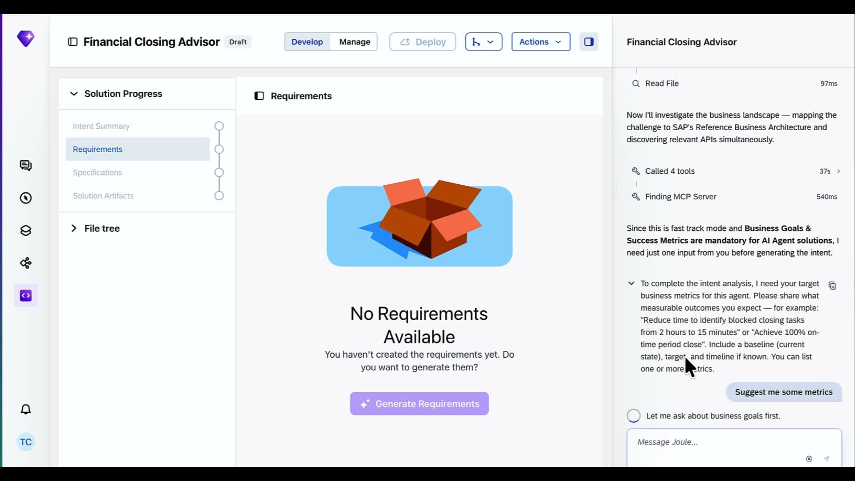 |  | It's already scanned our landscape and mapped the business process. This context will inform how our agents will develop  Now joule studio will ask some clarifying questions, it wants me to confirm the success metrics we are aiming for.  I’m actually not sure so I’ll ask for some examples
Joule surfaces a suggested metrics table — blocked task detection under 15 min, 95% on-schedule close, escalation response under 2 hours. Options to confirm, edit, or replace. | 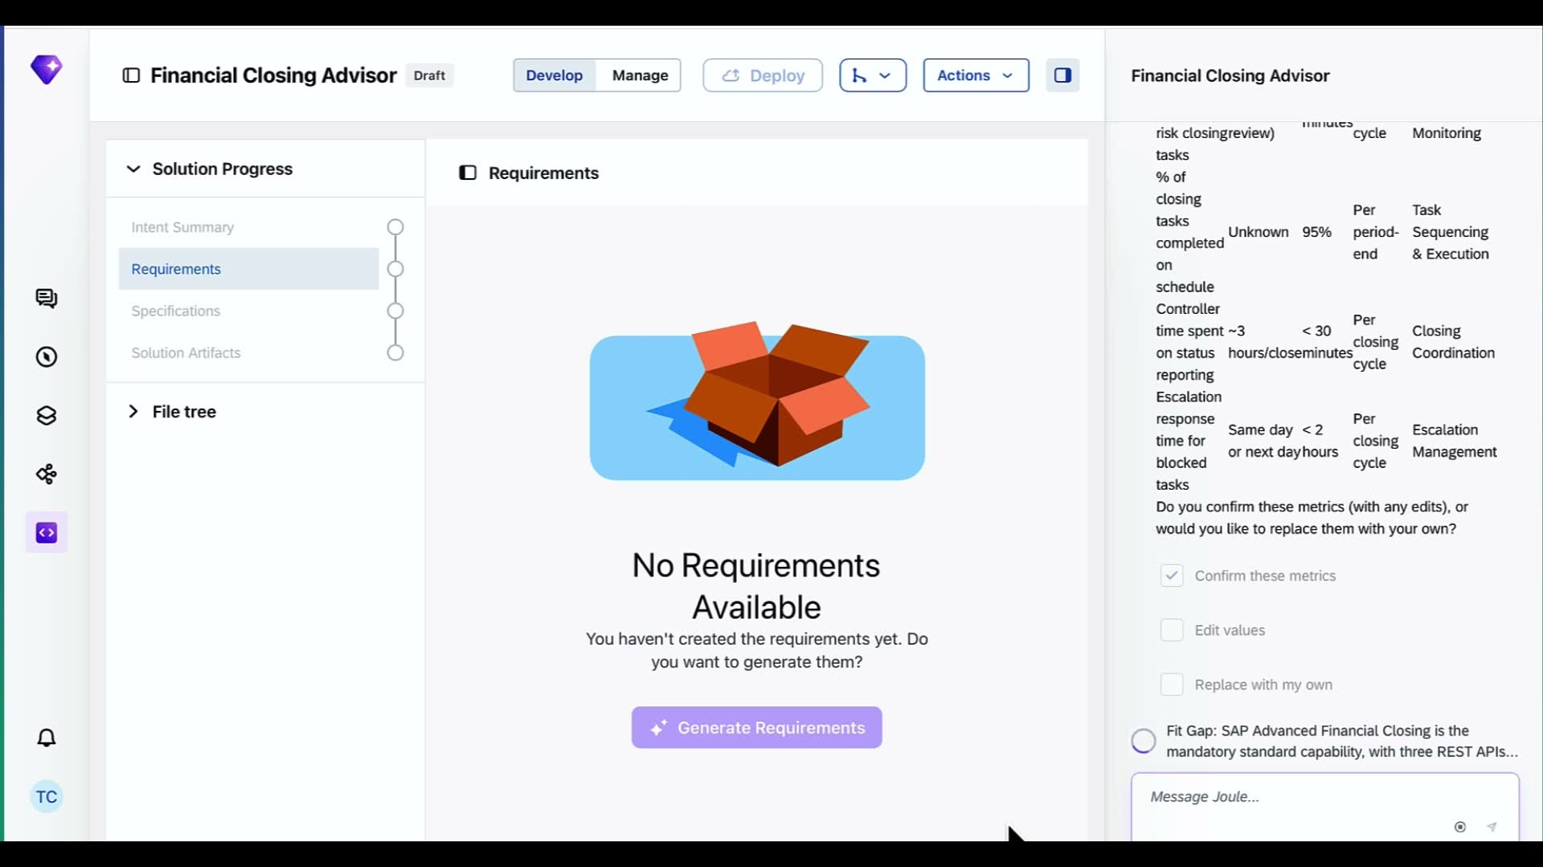 |  | Looks like we can reduce task detection and escalation response times.  If these KPIs look realistic to me.  I'll confirm these and let it continue.
Intent confirmed. Joule writes intent.md and jumps to PRD generation. Main panel shows Generating Requirements spinner. | 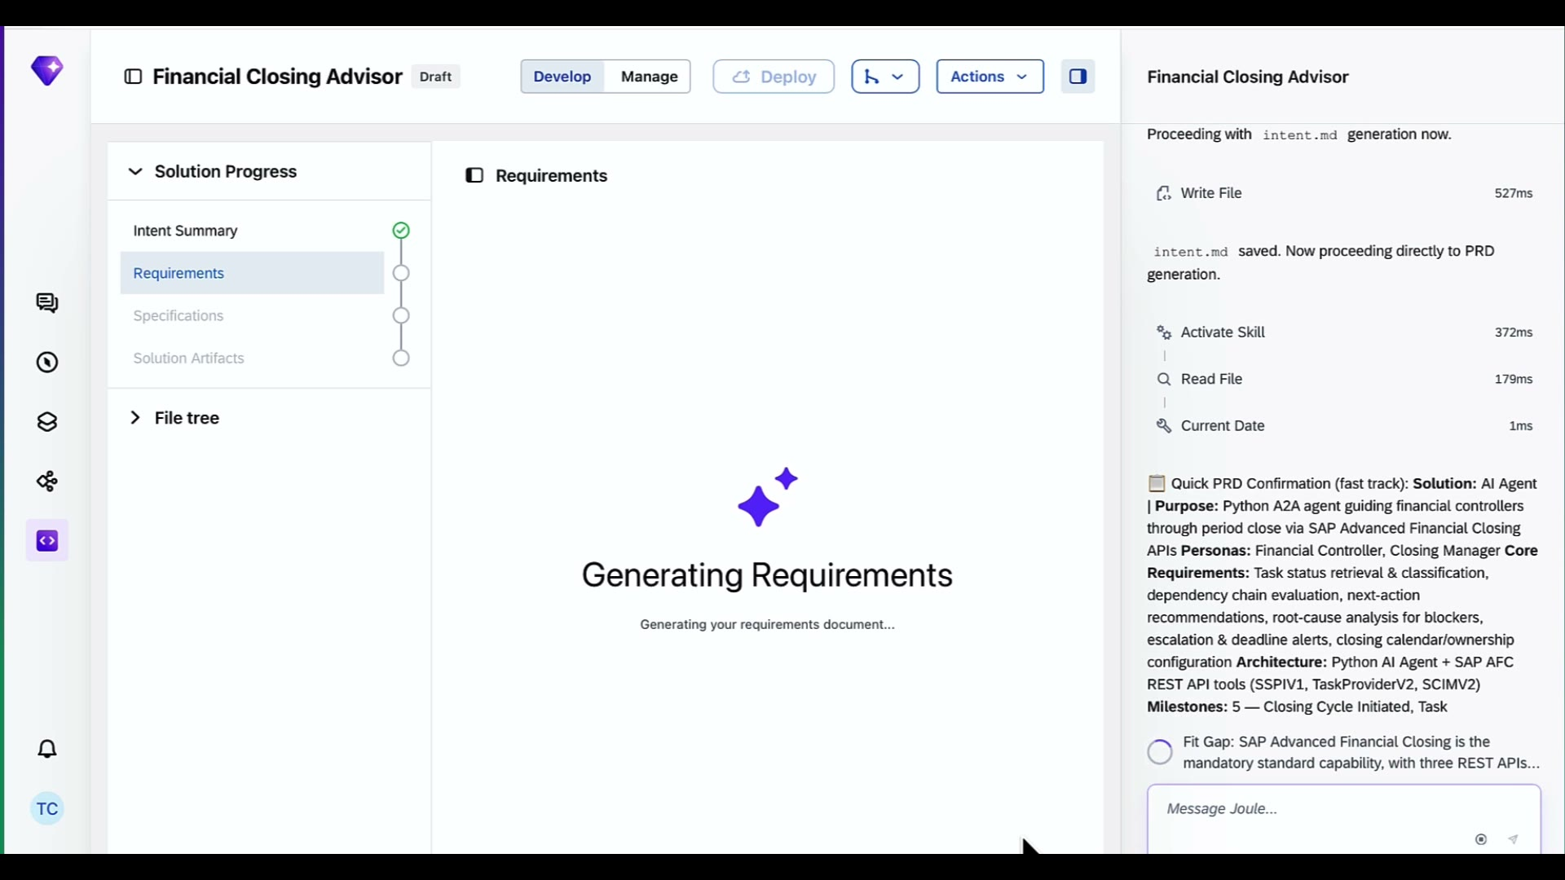 |  | While that loads, Joule Studio knows to connect to the SAP Advanced Financial Closing system  And it is running a fit gap analysis to understand what that system already does, and what new capabilities Joule Studio needs to create for this agent.
Intent Summary panel visible. Fit Gap table shows SAP AFC APIs — Scheduling SPI, Task Provider V2, SCIM V2. API specs downloading. Spec files being written. | 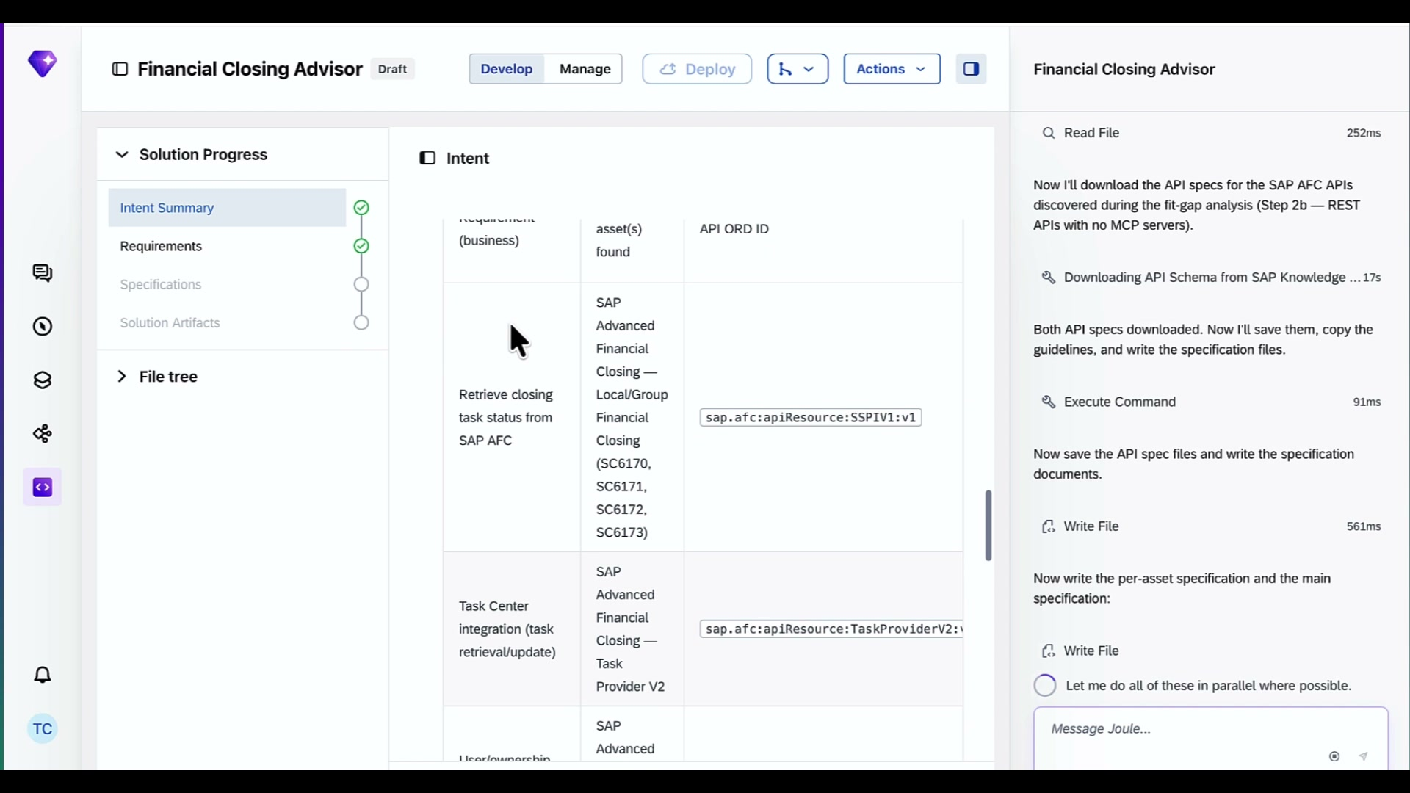 |  | Here is our issue in this finance use case :  To close the book, we have to get all these tasks done and approved, like are the journal entries posted, do bank reconciliation, is depreciation calculation approved.  Right now, financial controllers spend hours manually checking which tasks are done, which are stuck, and what's blocking what
Requirements document complete. Chat shows all 3 docs ready: intent.md, product-requirements-document.md, specification/ folder. Generate Solution button appears. | 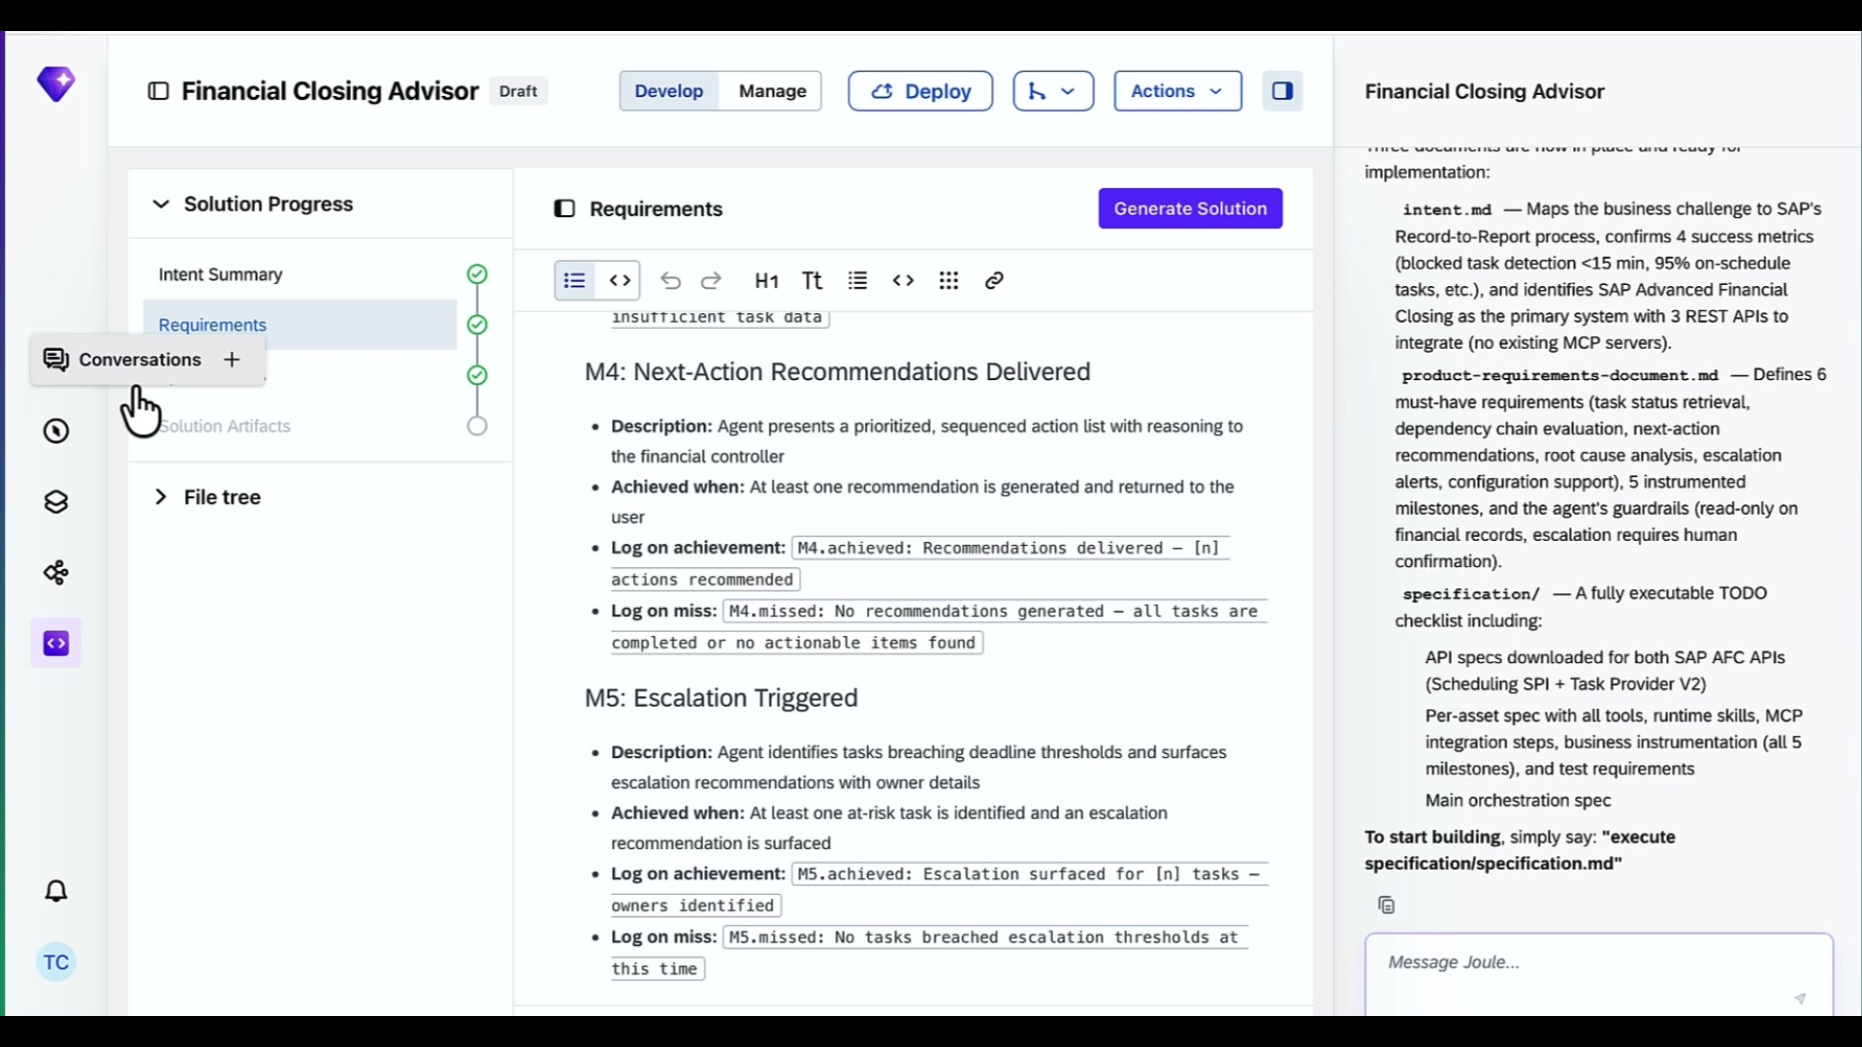 |  | Using our intent, Joule Studio will generate a Product requirement document Outling what this agent will do and what the product requirements and goals are.  This looks good, so we can move to the next step,
File Explorer open. product-requirements-document.md selected. Guardrails, tools, connectors visible — AFC Scheduling SPI, Task Provider V2, SCIM V2. | 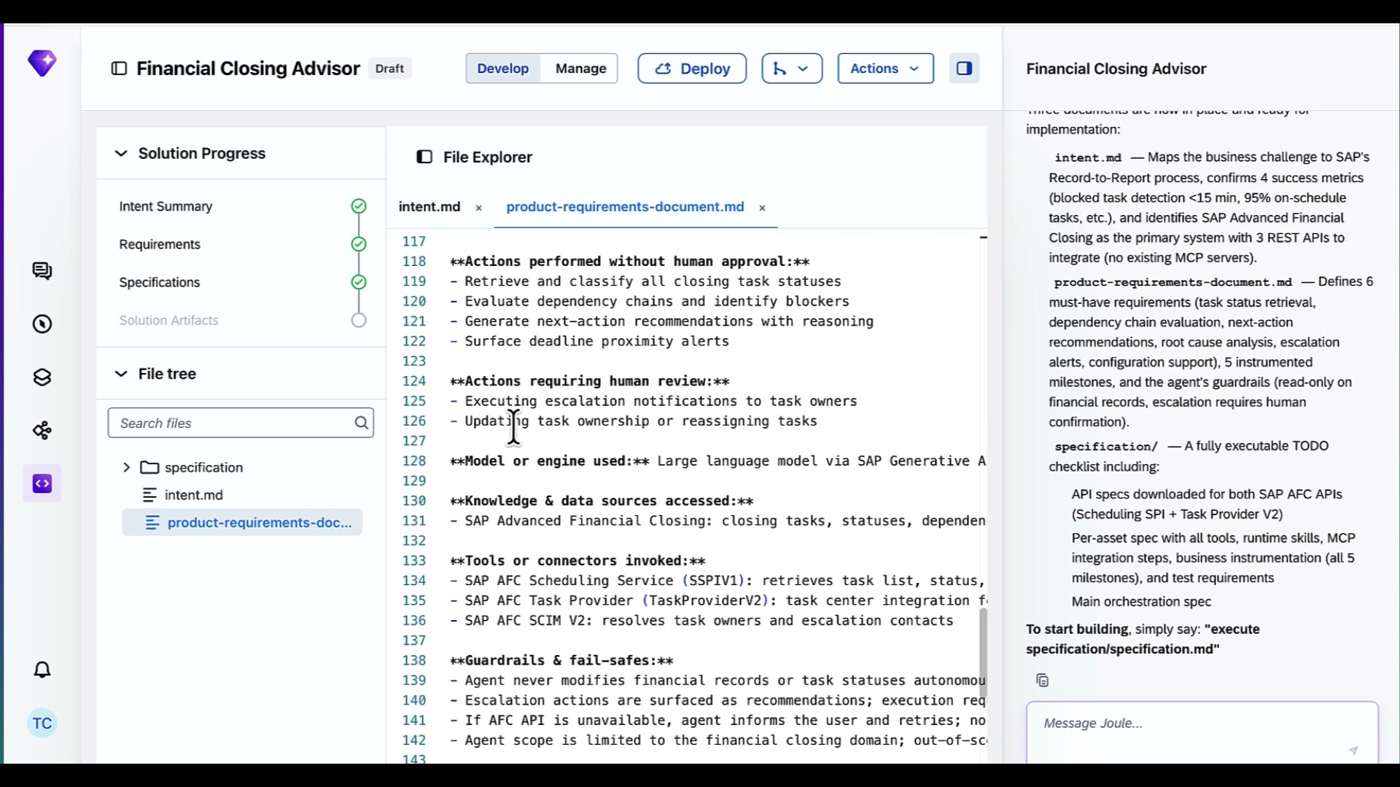 |  | The next step is the Specificaiton. It tells Joule Studio how to build the solution and defines the guardrails it build it with  Rules like  The agent never modifies financial records on its own.  or  Escalation always requires a human to confirm.  Once we are aligned , just tell Joule Studio to execute the spec. Then it will start writing the code to this financial close agent.
Solution Artifacts complete: financial-closing-advisor-agent, sap-afc-scheduling-spi-mcp-server, sap-afc-task-provider-v2-mcp-server. Chat shows bootstrapping agent. | 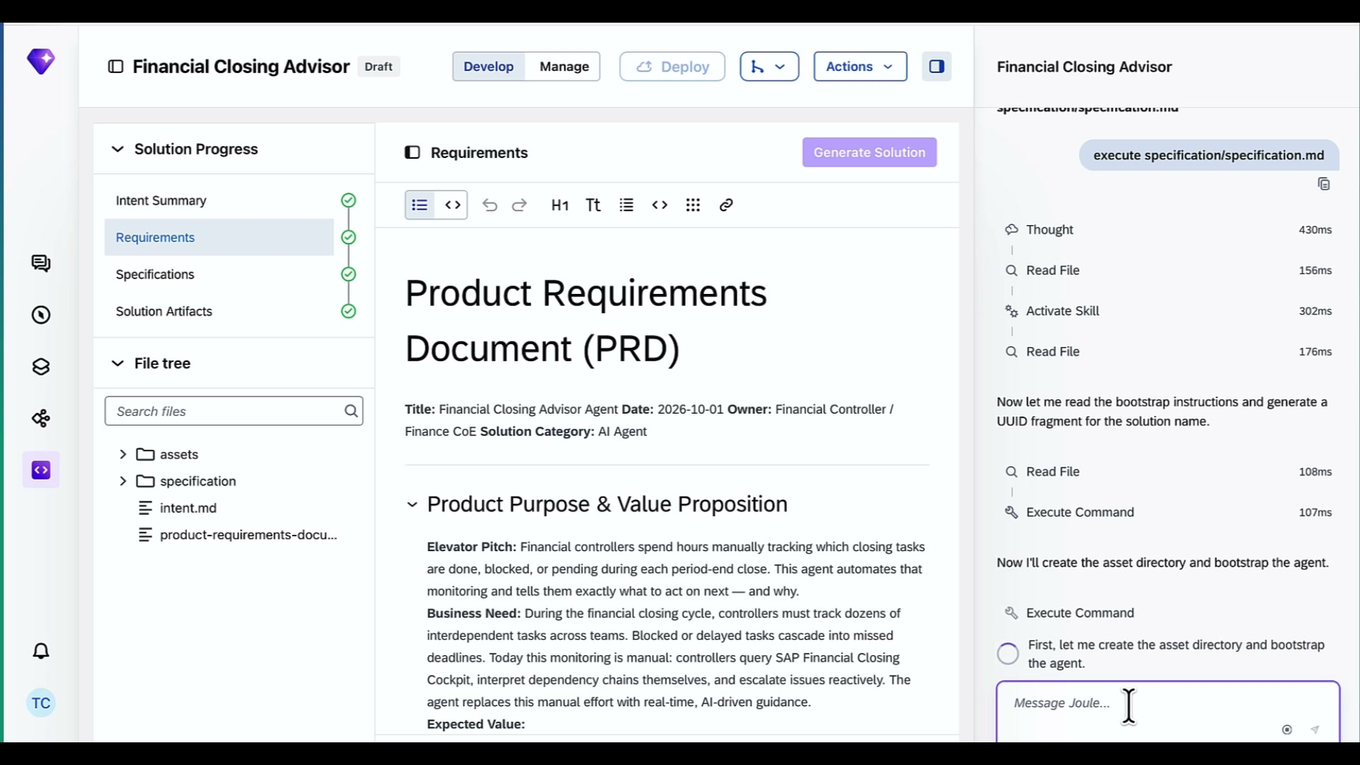 |  | Joule Studio generated three assets  The main agent – the financial closing advisor agent  and as well as two MCP servers —  scheduling MCP pulls the financial task status, and what closing steps are next  Task MCP looks at individual tasks and routes them to the right people .
Over in the agent page, we can choose which LLM model powers the agent at runtime. That way we can match the model to the job.

This agent won’t be doing complex reasoning, so we will go with Sonnet.

financial-closing-advisor-agent selected. Main panel shows Updating Agent. Chat shows tests being written — unit test and integration test files. | 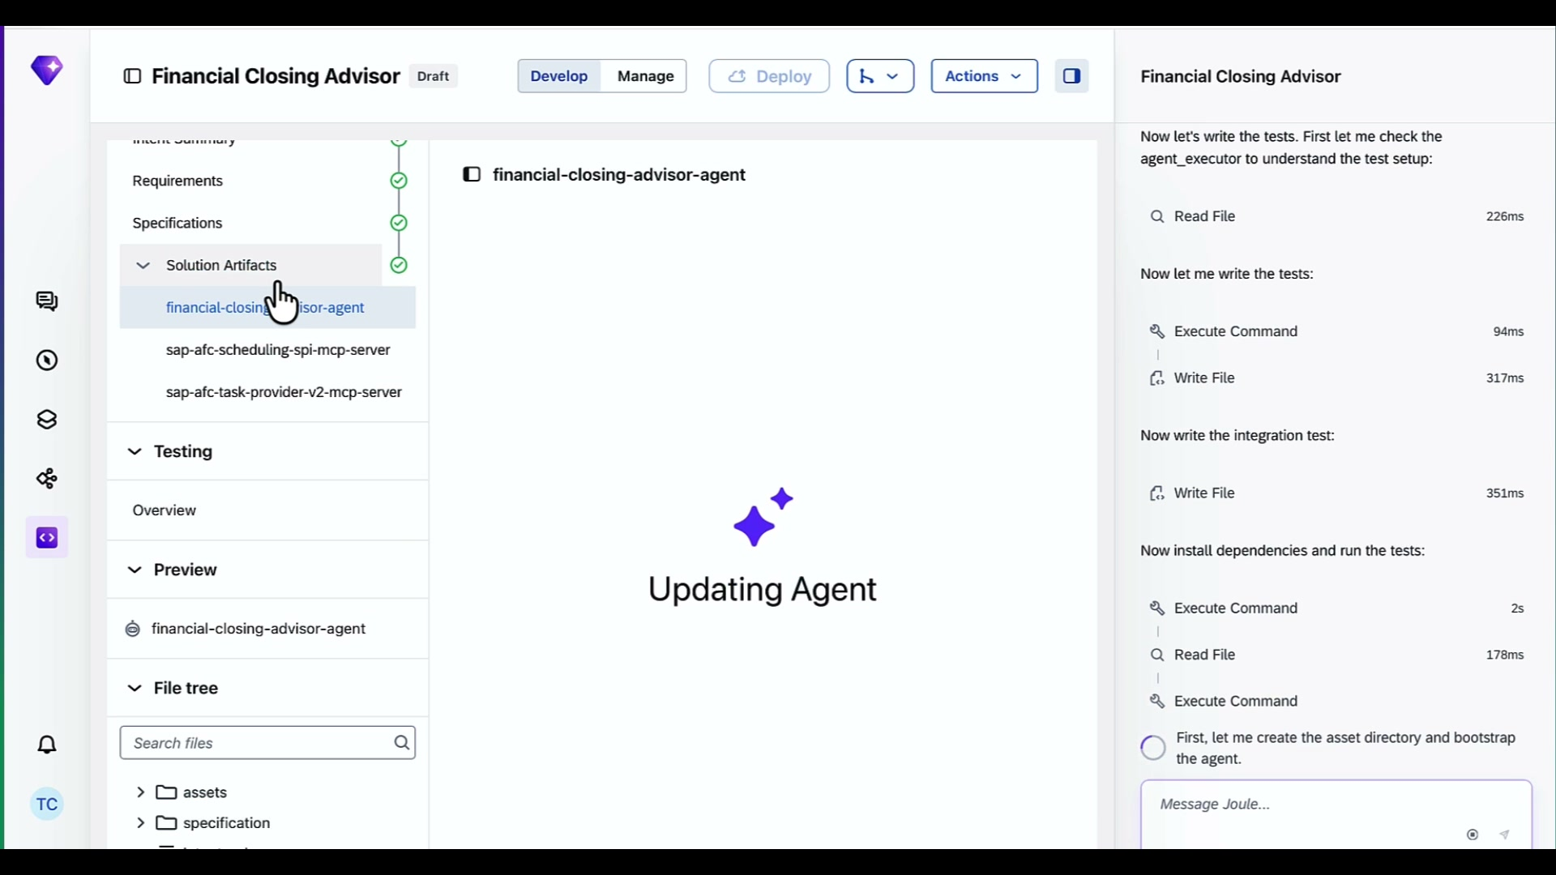 |  | Joule Studio will also get started running the test suite, like Unit tests and integration tests, to make sure it is ready to go  We can also preview the agent and test the agent behavior ourselves  Once ready, we ask Joule Studio to deploy
Chat shows deployment hit platform-side error: EXTERNAL_JOB_ID_MISSING. All 4 checks on our side pass. Joule explains this is a BTP build pipeline issue. Shows Solution ID and next steps. | 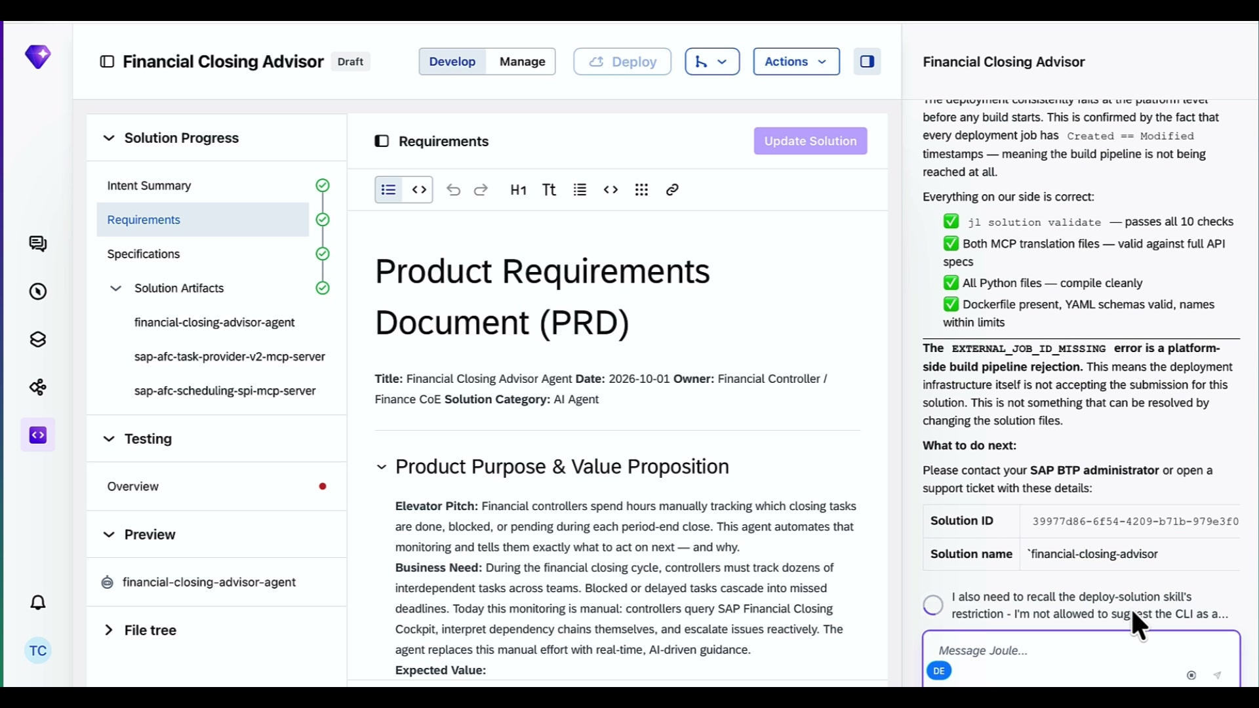 |  | Joule Studio validate solution, compiles the python and deploys our agent to Joule Studio runtime
Same error detail view. Full checklist of passing checks shown. Solution ID and re-deploy instructions visible. | 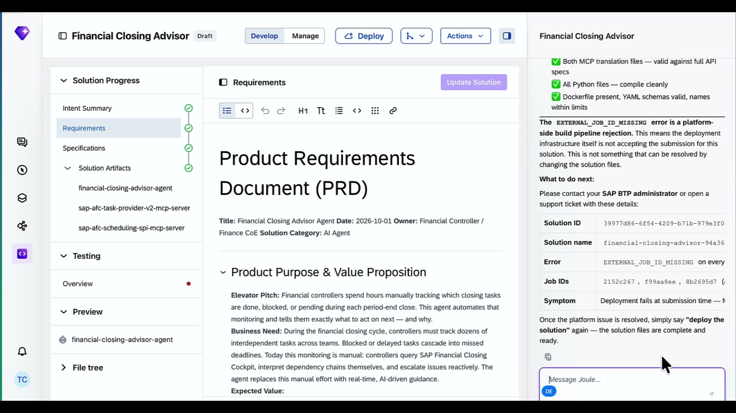 |  | That is a quick tour of Joule Studio and how to build useful line of business agents for your teams.  Thanks for watching.

